Title: RoboRunner

Team Name: Team X

Name of Team Members:

* Zeng Yang
* Husam Suoamra
* Jordi Trejo
* Bryant De Luna-Peralta

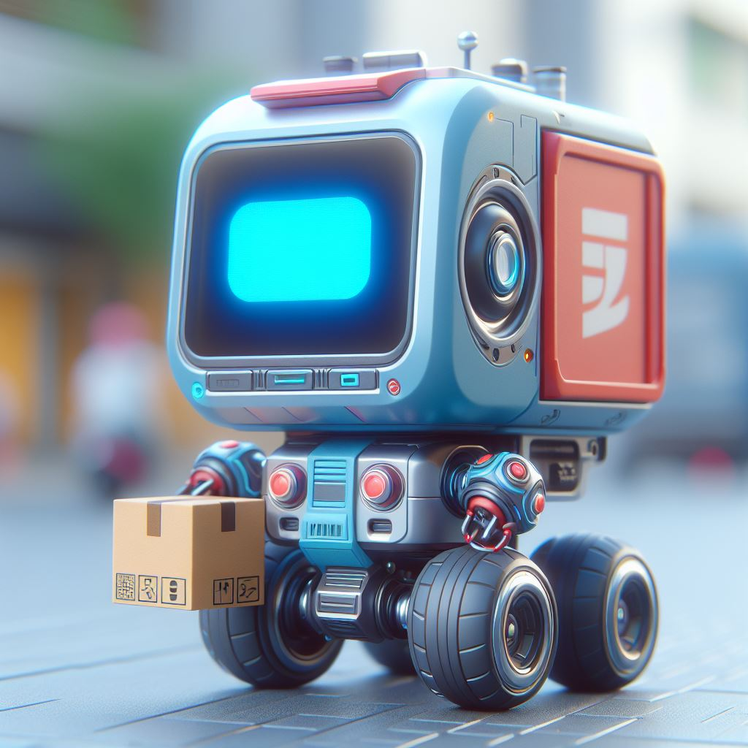

| Genre | Platform | Number of Players |
| --- | --- | --- |
| Adventure/Platformer | PC | 1 |

* A delivery robot that tries to deliver food while avoiding dangerous city obstacles such as cars, humans, and wild animals.
* The delivery robot can obtain power-ups to help itself deliver food fast.
* The faster the robot delivers the food and the better condition it is in will result in better tips

Zeng Yang:

Zeng is the designer of the team. He is always focused on the details, ensuring things run smoothly and look nice. He holds quality to a high standard and follows through with his assignments

Husam Suoamra:

Husam is the producer of the team. He has high expectations and thoughtful ideas. He is organized and ensures that the team is working efficiently.

Jordi Trejo:

Jordi is the artist of the team. His creativity motivates him and wishes to implement his ideas into the game's art.

Bryant De Luna-Peralta:

Bryant is the programmer of the team. He is able to apply concepts and code for his team’s ideas throughout the game. He understands what needs to be done and works hard to make sure things work.

**Details:**

* **Power-Ups**
  + The game features two unique power-ups designed to enhance the gameplay and provide strategic options for players:

1. Speed Boost
   1. Functionality: Temporarily increases the player's speed, enabling quicker deliveries across the game's various environments.
   2. Strategic Use: Ideal for covering large distances swiftly or making deliveries just before time expires. Availability is limited, requiring players to decide the best moments to activate it.
2. Phasing Ability
   1. Functionality: Allows the player to phase through objects for a brief period, enabling shortcuts through obstacles.
   2. Implementation Details:
      1. The game extends the phasing effect until the player exits an object if the ability's duration ends while inside an obstacle.
      2. A fail-safe mechanism is in place where staying within an object for too long results in a game over, adding a strategic layer to its use.
      3. This ability balances the need for speed with the risk of being trapped, encouraging careful path planning.

* **Win Condition**
  + The objective of the game is to complete all deliveries within a set time frame, with the following mechanics influencing the gameplay:
* **Deliveries and Time Limit**
  + Players must navigate through the game's levels to make all assigned deliveries before time runs out. Failing to complete deliveries in time results in a loss.
* **Scoring System: Tips**
  + Delivery Speed and Satisfaction: The speed of each delivery and the resulting customer satisfaction determine the size of the tips received.
  + Tips as Score: The total amount of tips earned acts as the player's score, reflecting their efficiency and skill in navigating the game's challenges.
* **Rating System**
  + A tiered rating system evaluates player performance, with up to three stars awarded based on total tips earned:
    - 1 Star: Completion of all deliveries with basic satisfaction.
    - 2 Stars: Moderate satisfaction and tips.
    - 3 Stars: High satisfaction with quick deliveries, yielding maximum tips.
* **Mastery and Replayability**
  + Encourages players to not only achieve all deliveries but to do so with the highest efficiency and satisfaction possible.
  + Bonus objectives and hidden challenges can offer extra tips or special power-ups, rewarding exploration and skilled play.
  + Levels
    - 1-2 will consist of being in the downtown area surrounded by vehicles and humans
    - 3 will reach a more suburban area with more prevalent animals like birds, squirrels, etc.
    - 4 will have the delivery robot reach the nearby mountain where wild animals appear more and vehicles will become harder to avoid
    - 5 will have a mixture of all, going through the city, the suburban, and a nearby forest



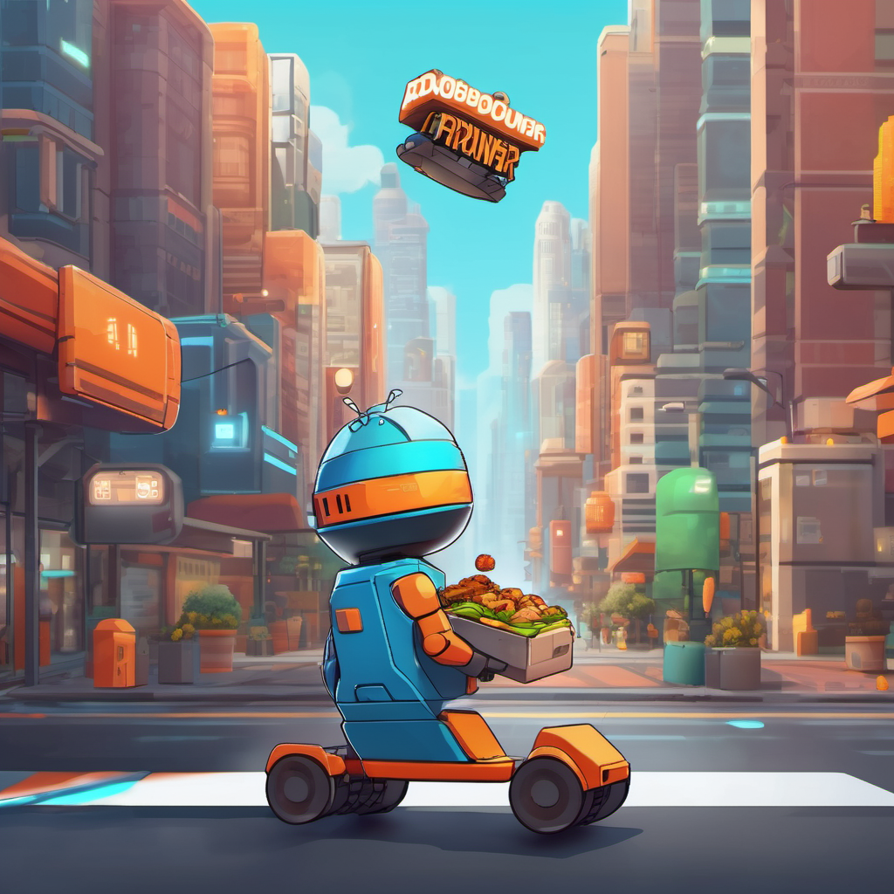



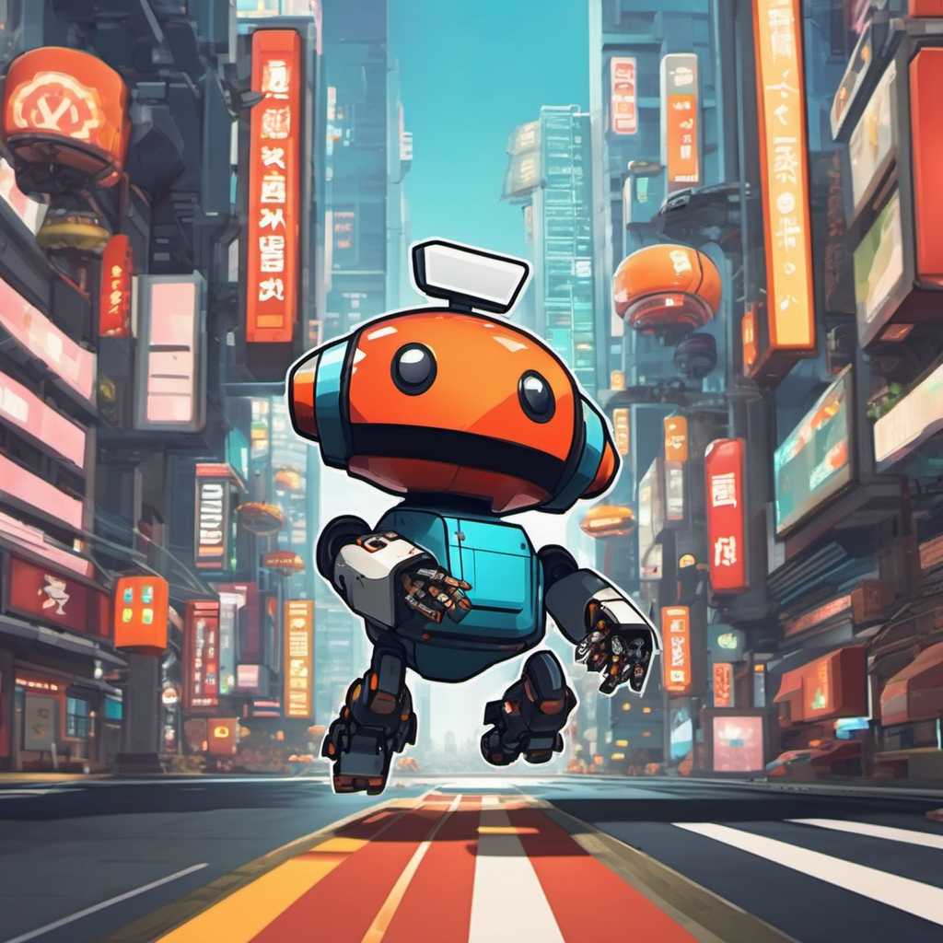

Images created by PIXLR <https://pixlr.com/image-generator/>